CHEMICAL ENGINEERING TRANSACTIONS  VOL. , 2023 | A publication of
The Italian Association
of Chemical Engineering
Online at www.cetjournal.it

Guest Editors: Sauro Pierucci, Jiří Jaromír Klemeš
Copyright © 2023, AIDIC Servizi S.r.l.
ISBN 978-88-95608-98-3; ISSN 2283-9216

Recycling Single Use Plastics to Useful Chemical Intermediates
Nasser J Alqahtani, Edidiong Asuquo, Christina Charalambous, Arthur Garforth,*
Department of Chemical Engineering, University of Manchester, Oxford Rd, M1 39PL
*arthur.garforth@manchester.ac.uk
Polymers are extremely stable and with rising landfill costs, forthcoming extended producer responsibility tax and the drive towards a circular economy, there is an increasing need to redirect polymer waste from landfill/energy recovery towards enhanced recovery of the raw materials/feedstocks. The COVID pandemic has introduced a significant amount of personal protective equipment (PPE) single use plastics in the form of facemasks into our global ecosystem, which is increasingly becoming an environmental issue due to their increasing non-biodegradability and with declining landfill capacity, this makes plastic recycling a necessity. Chemical recycling stands out as a viable method of converting plastic waste into valuable products, especially liquid fuels (naphtha) and liquefied petroleum gas (LPG). Chemical recycling of plastics can also serve as a route to introduce circularity into the plastic supply chain. This research study is focused on investigating the use of heterogeneous catalysts (zeolites Beta and USY) for the conversion of polypropylene (PP) and single use facemasks into chemical feedstock using hydrocracking. Catalytic hydrocracking reactions were carried out between 270-330 ̊C at 20 bar hydrogen pressure for 30-60 minutes. The results indicates that USY zeolite was more effective than zeolite beta due to its higher selectivity to liquid products. Moreover, the presence of highly acidic catalysts can be used to suitably recycle polymers into useful hydrocarbons with C₃-C₁₆ product distributions.
  - Introduction
Plastics play an important role nowadays and have become essential everyday materials. They are present in every aspect of our lives, including our food supply, clothes, structures, transportation, communications, healthcare, recreation, and entertainment. Plastics are extremely stable and with rising landfill costs, forthcoming extended producer responsibility tax and the drive towards a circular economy, there is an increasing need to redirect polymer waste from landfill/energy recovery towards enhanced recovery of the raw materials (Clark et al., 1999, Chalmin, 2019). Recently, the COVID pandemic has introduced a significant amount of personal protective equipment (PPE) single use plastics in the form of facemasks, face shields and gowns with over 0.5 billion in England used in the first six months of the pandemic (Rizan et al., 2021). Globally, 129 billion face masks and 65 billion gloves are consumed monthly by 7.8 billion people. Moreover, the mismanagement of PPE resulted in significant environmental pollution and economic losses. The contamination of the environment has also increased exponentially due to the COVID-19 pandemic with indiscriminate disposal of personal protective equipment (Prata et al., 2020). Therefore, recycling polymers is required to minimise their influence on the environment. Since several tertiary recycling techniques provide valuable chemicals or fuels, they are attractive (de la Puente et al., 2002). There has been a substantial amount of research focused on plastic waste pyrolysis (Sharuddin et al., 2016). Although it may produce beneficial products and provides an alternative to other disposal methods, it still has challenges with process efficiency (Rollinson and Oladejo, 2019), which catalysis may be able to address. For the hydrocracking of polymer feedstocks, previous research has revealed metal-loaded zeolite catalysts as attractive options with faster reaction times under benign conditions (Akah et al., 2015). The conversion of plastic waste into valuable chemicals such naphtha or short-chain hydrocarbons via the hydrocracking is a significant improvement over the existing methods (Kaminsky and Zorriqueta, 2007). A bifunctional catalyst, like zeolite, that has an acidic function to enhance the cracking usually offered by a greater surface area support, is essential for hydrocracking (Akah et al., 2015). Bin Jumah et al. demonstrated that by optimising the reaction's conditions to (330 °C, 20 bar H₂, and 30 min) over zeolite Beta impregnated with 1% platinum, a high conversion of virgin and waste polymers was attained(bin Jumah, et al., 2021). As a route out of this environmental challenge, this research proposes the use of a chemical recycling process for the transformation of single use PPE (such as facemask) into a valuable chemical intermediate (feedstock), such as, naphtha. Hence, this work focuses on a catalytic study using both thermal analysis to screen potential catalysts and the hydrocracking of virgin polypropylene (PP) and initially PPE facemasks, as a relatively pure waste stream (bin Jumah et al., 2021).
  - Experimental
    - Materials and samples preparation
In this study ammonium form Beta (Si/Al ratio = 12.5) and acidic hydrogen form USY (Si/Al ratio = 15) zeolite catalysts were used, were supplied by Zeolyst International Inc, code no. CP814E (Beta zeolite) and CBV720 (USY zeolite), respectively. They were metal loaded using tetraamine platinum (II) chloride hydrate (Pt [NH₃]₄Cl₂·H₂O, Mw ~ 334.11 g/mol, code no. 323330) with a purity of 99%, was supplied by Sigma Aldrich. Virgin PP was obtained in pellet form (<400 μm) from Goodfellow Company (code 68 no. PP306312). Single use facemasks supplied by Yeso-med (type 2R surgical facemask) were used. The virgin PP was used directly in the reactor. The three layers of the facemask that are composed of PP; these were split initially. After that, the blue layer was cut into smaller pieces, and then placed within the reactor.
    - Catalyst preparation
For the synthesis of 1% Pt on USY zeolites, a known amount of the Pt precursor tetraamine platinum (II) chloride hydrate was mixed in water (100 ml) and the USY zeolite was added (10 g). Thereafter, the mixture was stirred overnight at a temperature of 65 °C to ensure dispersion of the metal on the catalyst surface and allow the slow evaporation of the water. After which the slurry was dried for 12 hours at 90°C in an oven. The catalyst powder was pelletised into 200–600 µm. For the Beta zeolite, it was converted from ammonium form to the hydrogen form by calcining in air for 5 hours at 550 °C. The zeolite powder was thereafter mixed with the required amount of Pt precursor tetraamine platinum (II) chloride hydrate and dissolved in deionized water and the protocol was as described for USY zeolite. Then the catalyst was activated in a tubular furnace at 360 °C for 4 hours with a 1 °C min⁻¹ ramping rate and a 50 cm³ min⁻¹ H₂ flow.
    - Characterization
A VERTEX 70v FTIR Spectrometer Bruker, using 32 scans and a resolution of 4 cm⁻¹ with the wavelength at range of 4000 - 400 cm⁻¹) was used to obtain information on the types of functional groups present in the single use facemask. Liquid nitrogen adsorption was used for the determination of surface area and pore characteristics of the two zeolites using the ASAP 2020 (Micromeritics). The identification and crystallinity of the catalysts were measured by X-ray diffraction (XRD) D2 Phaser (Bruker)
    - Thermogravimetric analysis (TGA) of pp and facemask
The TGA was carried out using a Q5000IR analyser (TA instruments) to study the thermal and catalytic behaviour of the virgin PP and blue layer facemask in the temperature range of 25-550°C, whilst the decomposition was carried out in a ceramic pan with mixed a 10 mg polymer and 1 mg catalyst under a 40 mL min⁻¹ N₂ flow at a heating rate of 5°C min⁻¹.
    - Hydrocracking reaction
Hydrocracking of PP and facemask was carried out using a 300 mL stainless steel reactor (Parr Instruments) stirred by an "anchor" style stirrer. The reactor was typically fed with 10 g of polymer and 1 g of catalyst (10:1 ratio), thereafter it was sealed by careful tightening of the bolts to prevent leaks. After that, the reactor was flushed with H₂ gas three times to eliminate any residual air, preventing the catalyst from deactivating on metal oxidation and moisture absorption. The reactor was then pressurised to the required reaction pressure (20 bar, typically) and a 60-minute leak test was conducted. The hydrocracking then followed at temperatures between 270 and 330 °C, and with an agitation speed of 400 rpm. The polymer remained isothermally constant for 30 and 60 minutes at all temperatures. After the reaction was completed, the reactor was speedily cooled to room temperature by air cooling, and the reaction products were collected. Finally, equation (1) was used to obtain the total conversion from solid to fluid. Gas chromatography was performed using a Varian CP3800 fitted with 50 m × 0.32 mm i.d. PLOT Al2O3/ KCl capillary column (gaseous samples) and an Agilent Technologies 6890N Network GC fitted with a 100 m × 0.25 i.d. PONA CB column (liquid samples).
$$Conversion \%=\frac{Solid \left(out\right)-( Polymer (in)+ Catalyst \left(in\right))}{Polymer \left(in\right)} ×100$$ | (1)
  - Results and discussion
    - Characterization results
The disposable face mask was separated into 5 parts as shown in Figure 1A. The filter layers 1-3 showing identical peaks in the two ranges of (2950-2836) cm⁻¹ (CH₃ asymmetrical stretching and CH₃ stretching respectively), symmetrical bending CH₃ at 1456 cm⁻¹ and C-C at 806 cm⁻¹, which are characteristic FTIR peaks of polypropylene (Figure 1B). The nose wire covering had identical peaks at 2916 cm⁻¹ which is the methylene asymmetric stretch, whereas the peak at 2847 cm⁻¹ is the symmetric stretch. At 1465 cm⁻¹ CH₂ bending and 717 cm⁻¹ split CH bending in Figure 1C. These peaks are similar to that of LDPE/HDPE thereby implying that the metallic covering is made from PE (Jung et al., 2018).
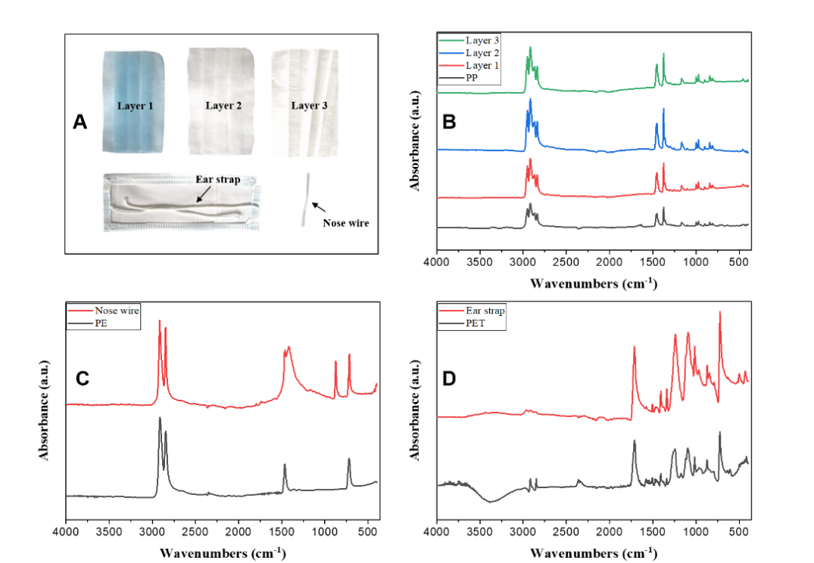
Figure 1: (A) a photo of the dismantled facemask, (B) FTIR of PP and the facemask three layers, (C) FTIR of PE and the facemask ear strap, (D) FTIR of PET and the facemask nose wire

The peaks of ear strap were identical to PET as shown in Figure 1D as the presence of a carbonyl group in conjugation with an aromatic ring appears at 1715 cm⁻¹. The asymmetric C-C-O stretching involving the carbon in the aromatic ring produces the second strongest peak at 1240 cm⁻¹. At 720 cm⁻¹, the aromatic C-H wagging appears, and at 1092 cm⁻¹, the O-C-C asymmetric stretching is split, implying that the ear strap also made of PET (Vijayakumar and Rajakumar 2012).
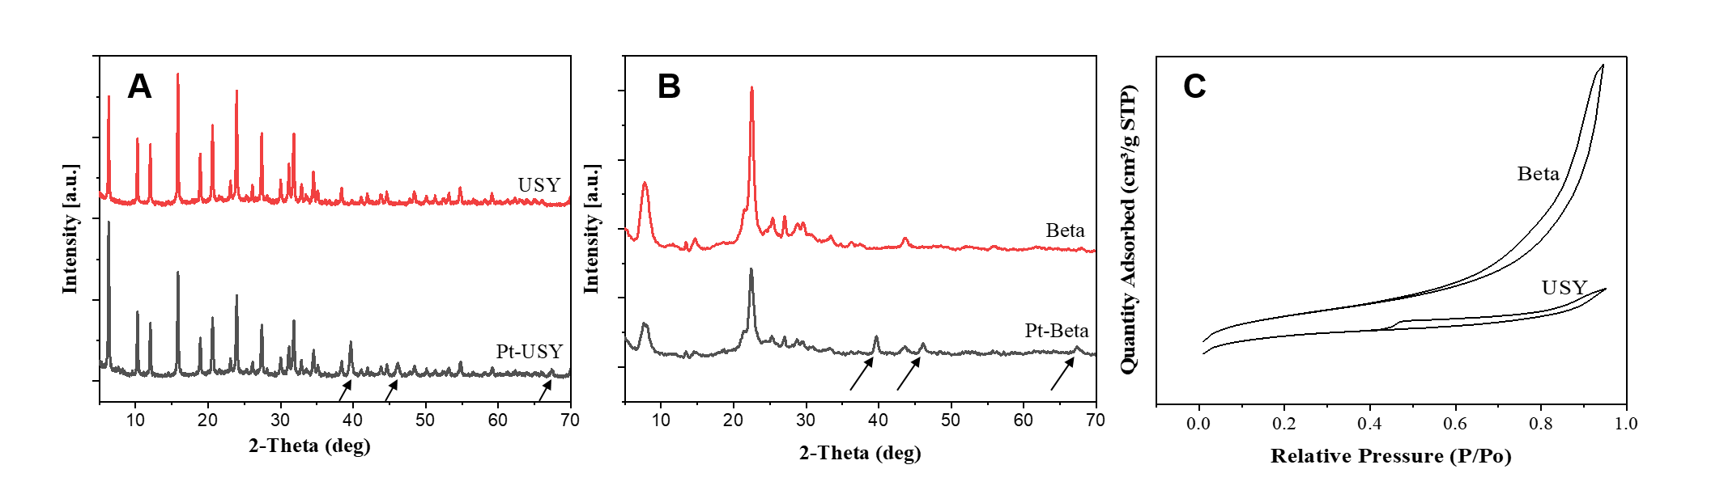
Figure 2: (A+B) the XRD for zeolites USY and Beta, impregnated with 1%wt Pt. (C) BET-N₂-adsorption/desorption isotherms curves for zeolites Beta and USY
Figure 2 (A-B) displays the XRD patterns of the zeolites and compares the crystallinity of the modified zeolites with each of their parent forms. The average particle size was calculated using the simplified Scherrer equation to be around 20 nm, and the Pt diffraction peaks are reflected at 2θ = 39.66°, 46.21°, and 69.49°. However, it is clear that the crystallinity of the zeolites structure was not altered despite the introduction of Platinum. The N₂ adsorption-desorption isotherms for zeolites Beta and USY are shown in Figure 2C. The isotherms for the Beta zeolite indicate a steep rise at very low relative pressure, indicating the presence of micropores. The rise in USY zeolite is lower that of zeolite beta but both zeolites portray N₂ adsorption and desorption isotherms that can be associated as type IV. Furthermore, the hysteresis loop arising at P/P₀ > 0.4 is clearly apparent for zeolite USY, indicating that mesopores are formed by acid treatment of USY zeolite (Huang et al., 2017).
    - Polypropylene and facemask decomposition via TGA
The effect of the use of catalysts during polymer degradation via TGA was obvious, with USY zeolite being more effective in breaking down the polymer significantly faster than zeolite Beta. In addition, this can be related to the batch reactor hydrocracking temperatures (~270-330°C). These temperatures obtained from Table 1 may give an indication of the thermal window for hydrocracking with two processes differing (namely, the atmosphere being N₂ for TGA versus H₂ for reactor studies) and pressure (atmospheric for TGA versus 20 bar for hydrocracking).
Figure 3: Decomposition curves of PP and facemask with/without zeolites Beta (12.5) and USY (15) corresponding with inset DTG
Table 1: TGA summary of PP and facemask degradation
Polymer/Cat | T_{onset} | T_{max}
PP no cat  Facemask no cat  PP / Beta  PP / USY  Facemask / Beta  Facemask / USY | 400  380  355  360  275  190 | 440  435  389  385  345  330

    - Hydrocracking results
Disposable facemasks made almost entirely of polypropylene were employed as the feedstock, and catalysts Beta and USY were used to investigate how catalysts influenced the production of hydrocarbons of pandemic related plastic waste. During the thermochemical conversion of plastic waste, catalysts are essential in controlling product distribution (Yuan et al., 2022). Generally, increasing the temperature had the predictable effect of increasing the production of lighter products and introducing more gas. Herein, the conversion of PP and facemask at 300 °C and 330 °C showed the effect of molecular weight, with PP having a high boiling point due to its much higher molecular weight than the facemask sample as shown in Figure 4(A-B).
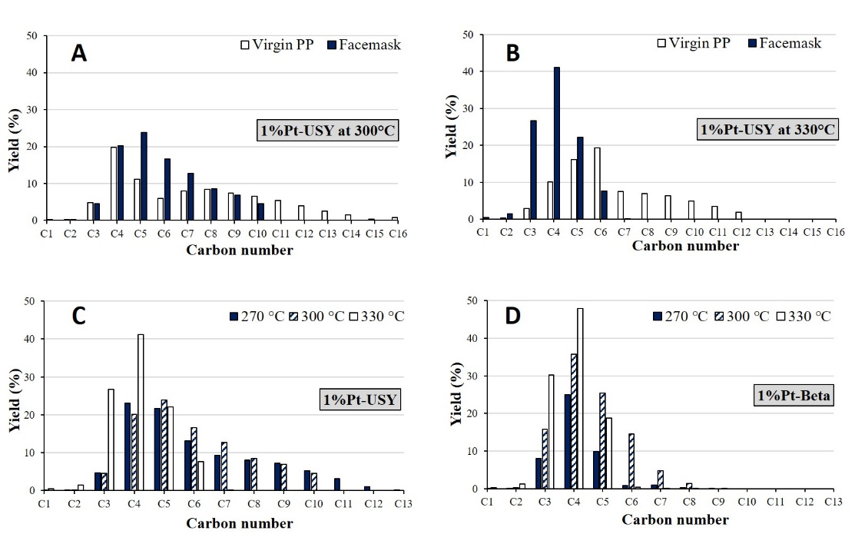
Figure 4: (A + B) Product distribution of PP and Facemask hydrocracking over 1%Pt-USY at 300 and 330 °C, (C+D) Facemask hydrocracking over 1%Pt-USY and 1%Pt-Beta at 270, 300 and 330 °C. (20 bar H₂)
In addition, this can be related to the TGA curves in Figure 3 which showed the decomposition of the facemask was faster than the virgin PP Further study using Pt-Beta (12.5) and USY(15) bifunctional catalysts produced streams rich in light, highly branched paraffins from virgin polymers at 330 °C (bin Jumah et al., 2021).

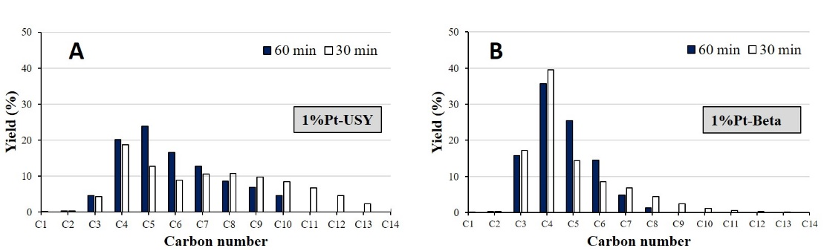
Figure 5: (A + B) Product distribution of Facemask hydrocracking over 1%Pt-USY and 1%Pt-Beta at 300 °C for 60 and 30 minutes (20 bar H₂).
As shown in Figure (4, C+D) shows a comparison between 1%Pt-USY and 1%Pt-Beta on facemask hydrocracking, and the products were within the range of (C₃-C₁₃) with zeolite USY indicating that it produces higher boiling point hydrocarbons than zeolite Beta (C₃-C₈).
Table 2: The selectivity of gas, liquid and solid of PP and facemask hydrocracking
Polymer | Catalyst | Temp | Time | Conversion % | Gas % | Liquid % | Residue %
PP  Facemask  PP  Facemask  Facemask  Facemask  Facemask  Facemask  Facemask  Facemask | 1%Pt-USY  1%Pt-USY  1%Pt-USY  1%Pt-USY  1%Pt-Beta  1%Pt-Beta  1%Pt-Beta  1%Pt-USY  1%Pt-Beta  1%Pt-USY | 300  300  330  330  270  300  330  270  300  300 | 60  60  60  60  60  60  60  60  30  30 | 87  98  98  99  45  99  99  97  96  98 | 34  29  30  72  45  55  99  33  68  32 | 53  69  68  27  0  44  0  64  28  66 | 13  2  2  1  55  1  1  3  4  2

Furthermore, the conversion at 270°C (Table 1) increased significantly from 45% (Pt-Beta) to 97% (Pt-USY) as well as a high amount of coke was observed at 300°C for 60 minutes, with the zeolite USY (2.7%), which was more than the zeolite Beta (1.6%) due to the presence of supercages within a ~1.3 nm diameter structure(Garforth et al., 1997). Finally, the influence of batch time for the hydrocracking of facemask showed that increasing time from 30 to 60 minutes resulted in lower carbon number products due to increased cracking, as shown in Figure 5.
  - Conclusions
Hydrocracking is a promising alternative to pyrolysis for the transformation of polymer wastes into useful chemical products that can be used by the chemical industry as feedstocks or fuels. This work found that zeolitic catalysts have great potential for reducing the energy needed for polyolefin plastic conversion. Catalytic hydrocracking of single use facemasks and polypropylene using bifunctional zeolite catalysts, at temperatures ranging from 270 to 330°C and a hydrogen pressure of 20 bar, resulted in low molecular weight hydrocarbons which can be classified as naphtha and liquefied petroleum gas. Detailed analysis indicates that the presence of highly acidic catalysts can be used to suitably recycle polymers into useful hydrocarbons with C₃-C₁₆ product distributions. The product distribution can be altered with manipulation of temperature, batch time, and Pt loading.
Acknowledgements
The authors would like to thank King Abdulaziz City for Science and Technology in Saudi Arabia for funding the project. We also thank the UK Catalysis Hub for resources and support for Dr Asuquo via our membership of the UK Catalysis Hub Consortium and funding through EPSRC grant EP/R027129/1.
References
Aguado J., Serrano DP., 1999, Feedstock Recycling of Plastic Wastes, The Royal Society of Chemistry Clean Technology Monographs (series editor Clark JH) Published by The Royal Society of Chemistry, Cambridge pp 129 -160.
Akah A., Hernandez-Martinez J., Rallan C., Garforth A., 2015, Enhanced Feedstock Recycling of Post-Consumer Plastic Waste, Chemical Engineering Transactions, 43, 2395-2400
Bin Jumah A., Tedstone A., Garforth A., 2021, Hydrocracking of virgin and post-consumer polymers. Microporous and Mesoporous Materials, 315, 110912.
Chalmin P., 2019, The history of plastics: from the Capitol to the Tarpeian Rock. Field actions science reports. The Journal of Field Actions, (Special Issue 19), 6-11.
De la Puente G., Klocker C., Sedran U., 2002, Conversion of waste plastics into fuels: Recycling polyethylene in FCC. Applied Catalysis B: Environmental, 36(4), 279-285.
Garforth A., Fiddy S., Lin Y. H., Ghanbari-Siakhali A., Sharratt P. N., Dwyer J., 1997, Catalytic degradation of high density polyethylene: an evaluation of mesoporous and microporous catalysts using thermal analysis. Thermochimica Acta, 294(1), 65-69.
Huang C., Li A., Chao Z. S., 2017, Heterogeneous catalytic synthesis of quinoline compounds from aniline and C 1–C 4 alcohols over zeolite-based catalysts. RSC Advances, 7(76), 48275-48285.
Jung M. R., Horgen F. D., Orski S. V., Rodriguez V., Beers K. L., Balazs G. H., Jones T. T., Work T. M., Brignac K. C., Royer S. J., Hyrenbach K. D., 2018, Validation of ATR FT-IR to identify polymers of plastic marine debris, including those ingested by marine organisms. Marine Pollution Bulletin, 127, 704-716.
Kaminsky W., Zorriqueta I. J. N., 2007, Catalytic and thermal pyrolysis of polyolefins. Journal of Analytical and Applied Pyrolysis, 79(1-2), 368-374.
Prata J. C., Silva A. L., Walker T. R., Duarte A. C., Rocha-Santos T., 2020, COVID-19 pandemic repercussions on the use and management of plastics. Environmental Science & Technology, 54(13), 7760-7765.
Rizan C., Reed M., Bhutta M. F., 2021, Environmental impact of personal protective equipment distributed for use by health and social care services in England in the first six months of the COVID-19 pandemic. Journal of the Royal Society of Medicine, 114(5), 250-263.
Rollinson A. N., Oladejo J. M., 2019, ‘Patented blunderings’, efficiency awareness, and self-sustainability claims in the pyrolysis energy from waste sector. Resources, Conservation and Recycling, 141, 233-242.
Sharuddin S.D.A., Abnisa F., Daud W.M.A.W., Aroua M.K., 2016, A review on pyrolysis of plastic wastes. Energy Conversion and Management, 115, 308-326.
Vijayakumar S., Rajakumar P. R., 2012, Infrared spectral analysis of waste pet samples. International Letters of Chemistry, Physics and Astronomy, 4, 58-65.
Yuan X., Kumar N. M., Brigljević B., Li S., Deng S., Byun M., Lee B., Lin C. S. K., Tsang D. C., Lee K. B., Chopra S. S., 2022, Sustainability-inspired upcycling of waste polyethylene terephthalate plastic into porous carbon for CO₂ capture. Green Chemistry, 24(4), 1494-1504.

